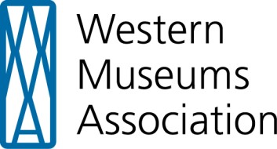

*Strengthening museums to serve diverse communities*

# Benefits of Seeking Professional Development Outside of Your Content Specialty

Professional development is essential for museum practitioners like you seeking to keep your knowledge and skillsets relevant in a rapidly changing field. At the WMA Annual Meeting we offer a cross-disciplinary approach that gives you the opportunity to expand your current abilities and develop the capacity to see your specialty in the context of the whole museum field.

At the WMA Annual Meeting:

* You will learn and grow with other attend as a community of practice. New and invigorating perspectives and ideas emerge from sessions and continue in casual conversations with colleagues during networking events.
* You will have the opportunity to develop an appreciation for the differences between disciplines. This perspective will help you understand how to approach problems from multiple viewpoints, which leads to a broader understanding of the issues being faced by the field.
* You can participate in areas outside your specialty, which promotes integration of ideas from multiple disciplines, fosters the acquisition of knowledge, and provides insight on how to apply that knowledge - all of which advance our collective understanding of the field.
* Speakers provide diverse, relevant, and accessible information that you can relate back to work at your home institution.
* Eight session tracks are offered, which provide cross-disciplinary learning opportunities for all museum professionals, regardless of specialty.
* You can explore collaborations you may never have considered that will expand your understanding of what is possible in the museum field.

Interested??

Visit: <http://www.westmuse.org/>

Or contact WMA’s Executive Director:

Jason B. Jones

wma@westmuse.org

707.433.4701